**TO START:**

* Create a new database named "CompanyDB."
* Create a schema named "Sales" within the "CompanyDB" database.
* Create a table named "employees" with columns: employee_id (INT), first_name (VARCHAR), last_name (VARCHAR), and salary (DECIMAL) within the "Sales" schema.

Note: on employee_id use squence **NOT** identity.

* Alter the "employees" table to add a new column named "hire_date" with the data type DATE.

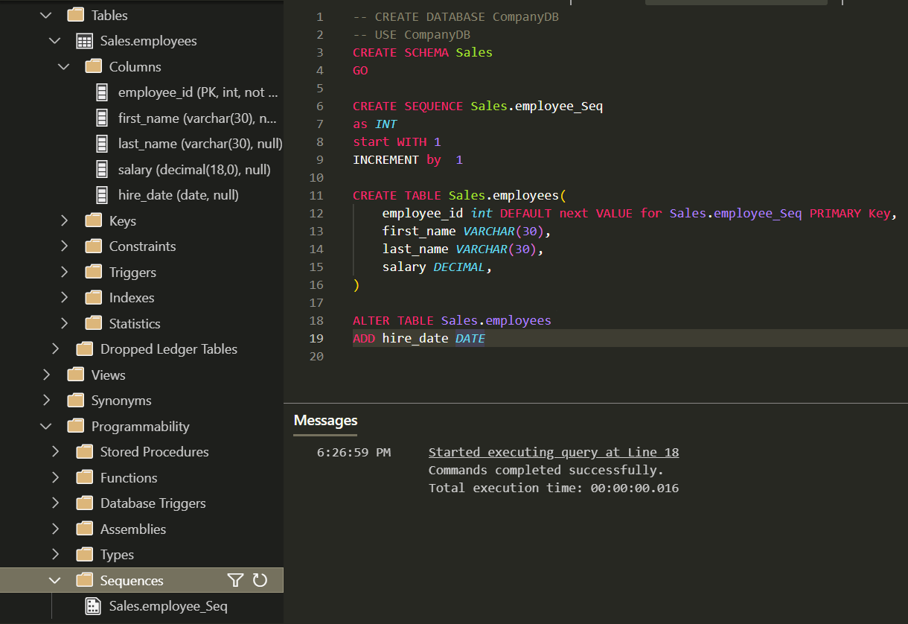

* **If you want** to Add mock data test use [https://www.mockaroo.com](https://www.mockaroo.com/)
* **DONE**

**DATA MANIPULATION Exercises:**

* Select all columns from the "employees" table.

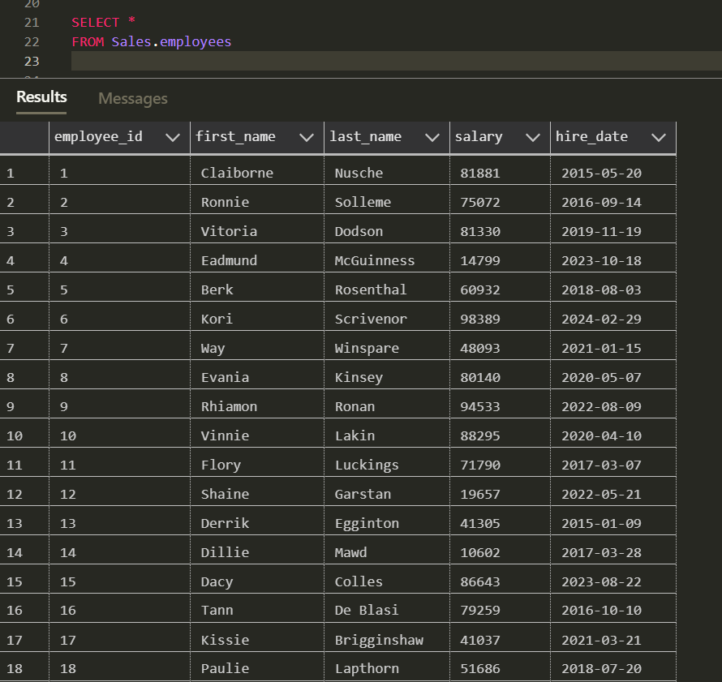

* Retrieve only the "first_name" and "last_name" columns from the "employees" table.

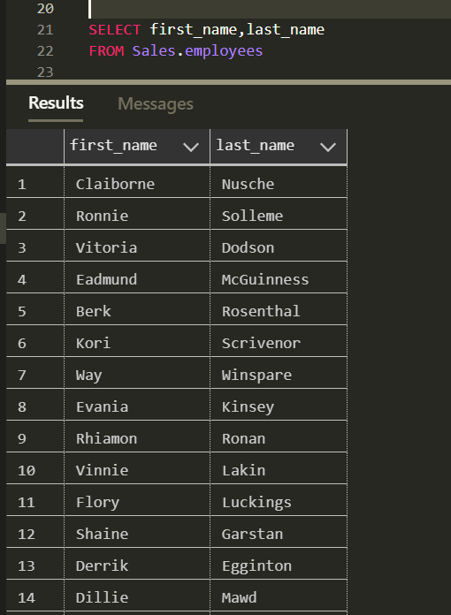

* Retrieve “full name” as a one column from "first_name" and "last_name" columns from the "employees" table.

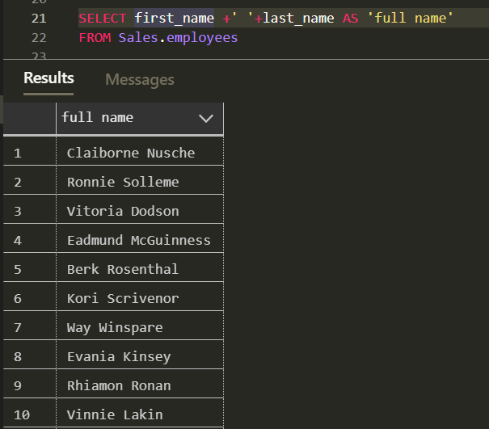

* Show the average salary of all employees.

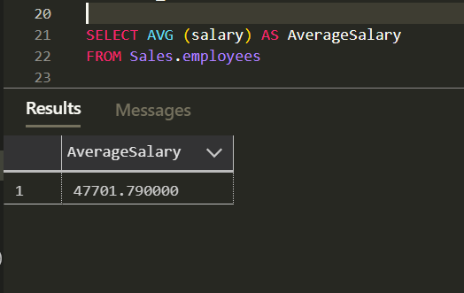

* Select employees whose salary is greater than 50000.

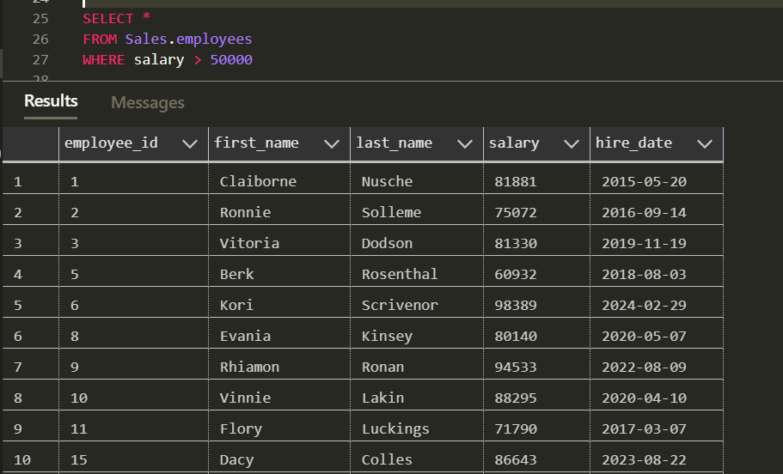

* Retrieve employees hired in the year 2020.

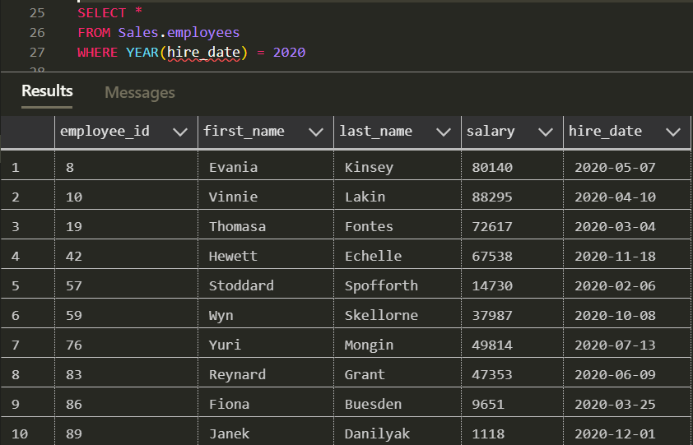

* List employees whose last names start with 'S.'

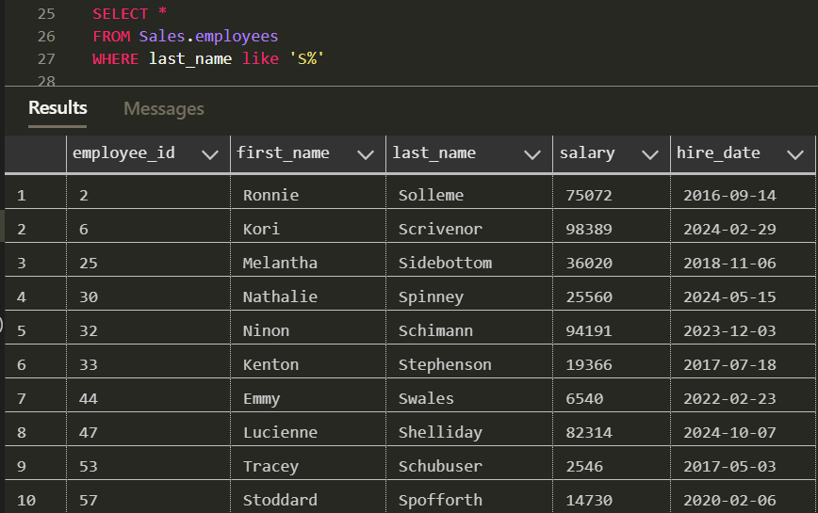

* Display the top 10 highest-paid employees.

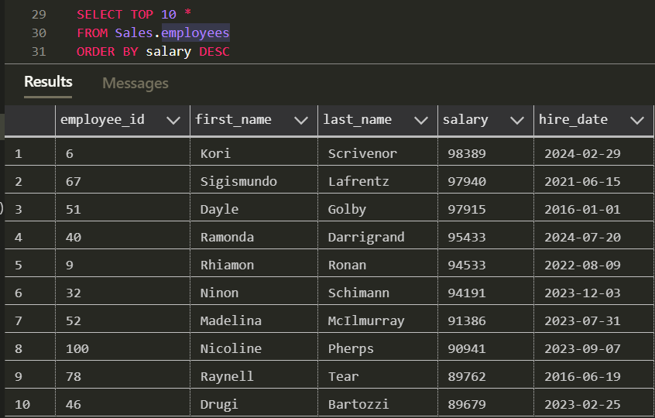

* Find employees with salaries between 40000 and 60000.

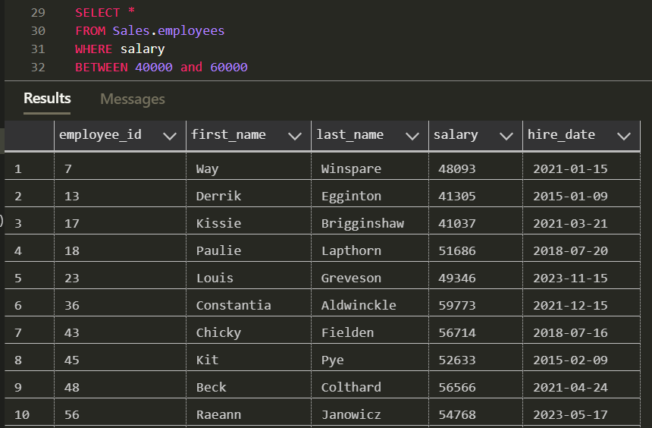

* Show employees with names containing the substring 'man.'

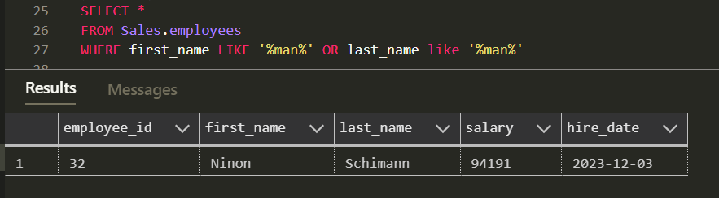

* Display employees with a NULL value in the "hire_date" column.

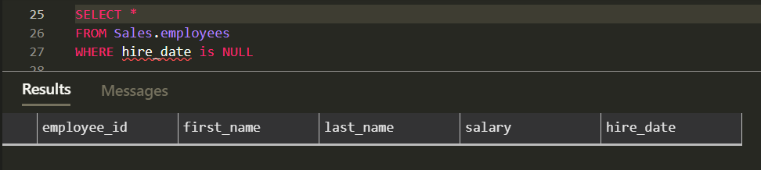

* Select employees with a salary in the set (40000, 45000, 50000).

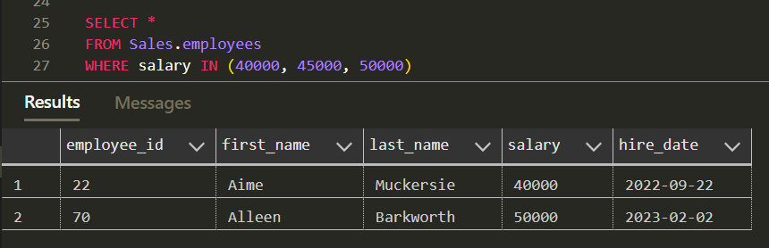

* Retrieve employees hired between '2020-01-01' and '2021-01-01.'

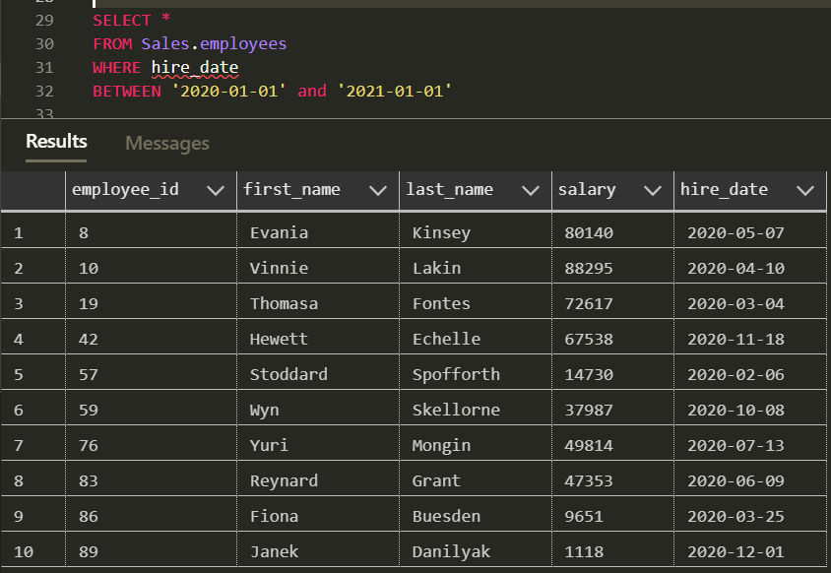

* List employees with salaries in descending order.

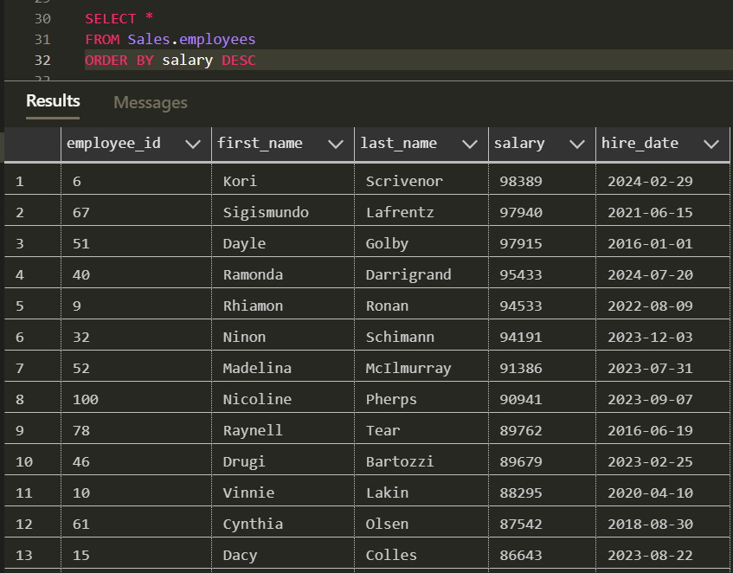

* Show the first 5 employees ordered by "last_name" in ascending order. 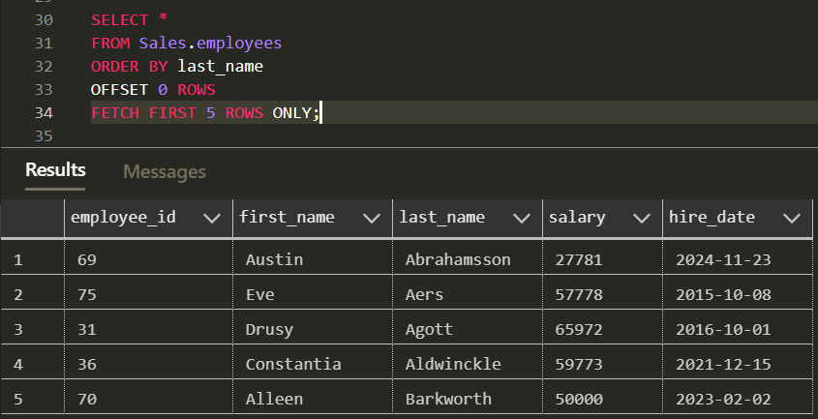 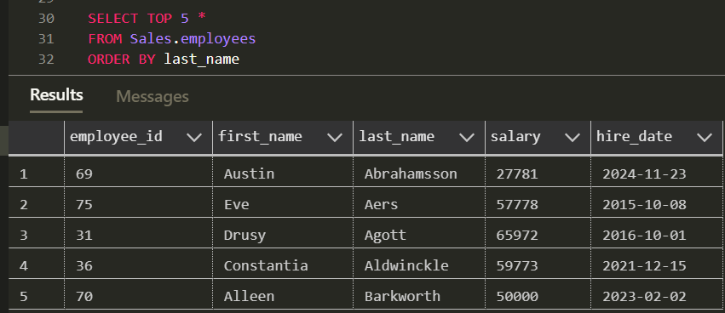
* Display employees with a salary greater than 55000 and hired in 2020.

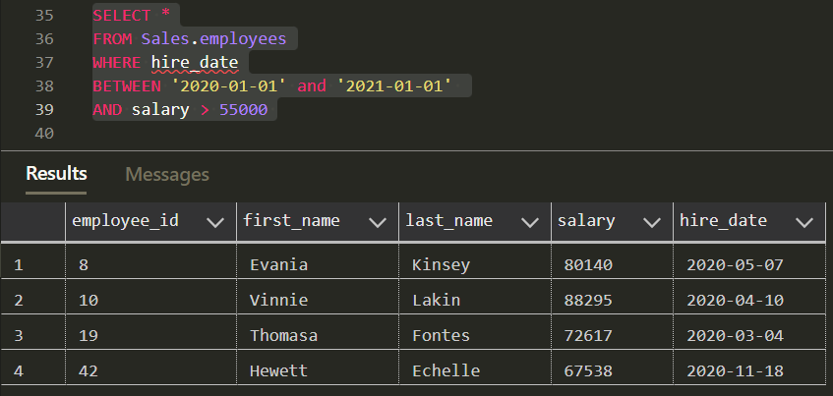

* Select employees whose first name is 'John' or 'Jane.'

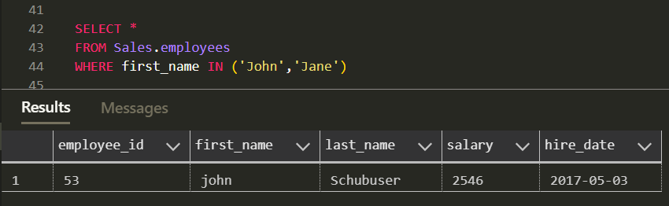

* List employees with a salary less than or equal to 55000 and a hire date after '2022-01-01.'

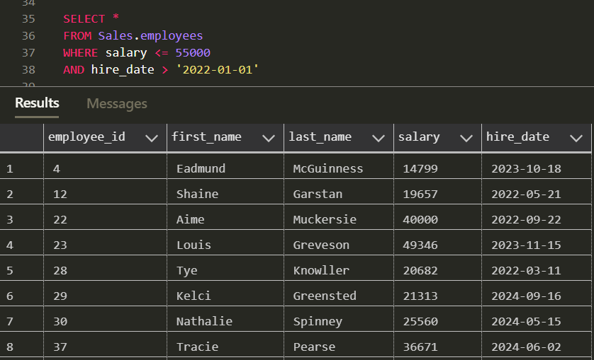

* Retrieve employees with a salary greater than the average salary.

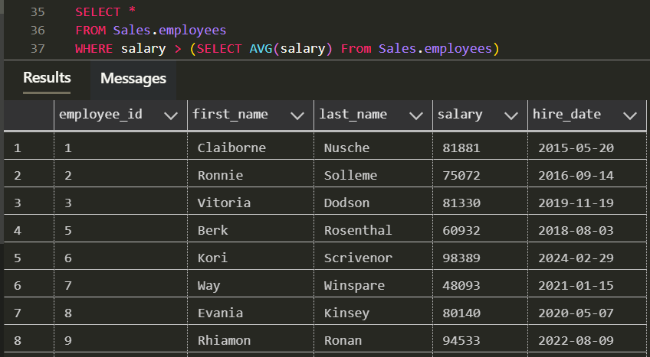

* Display the 3rd to 7th highest-paid employees.

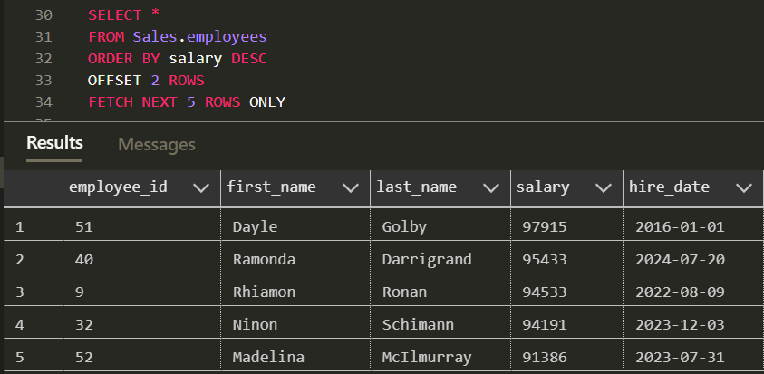

* List employees hired after '2021-01-01' in alphabetical order.

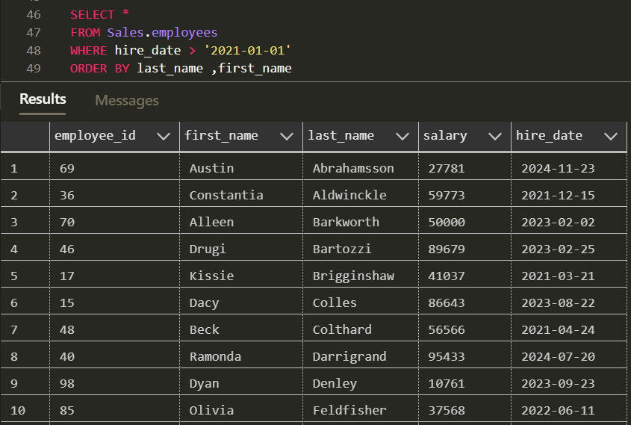

* Retrieve employees with a salary greater than 50000 and last name not starting with 'A.'

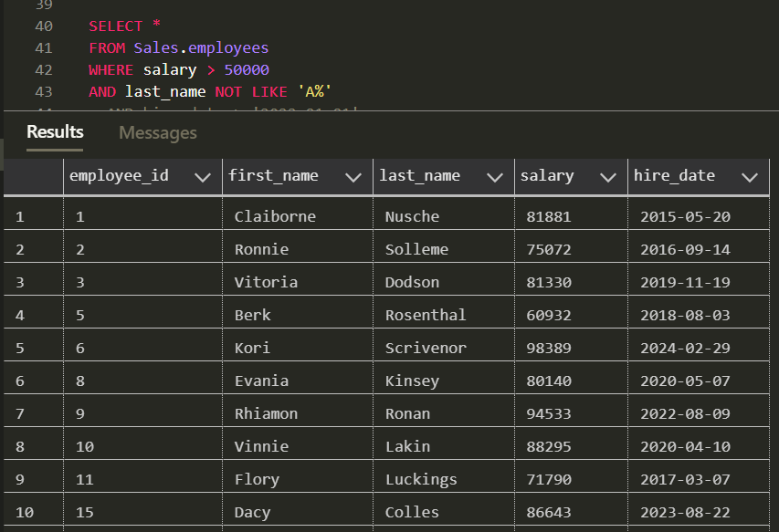

* Display employees with a salary that is not NULL.

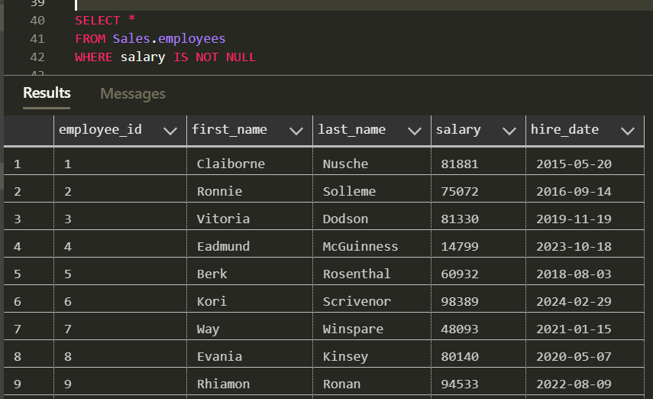

* Show employees with names containing 'e' or 'i' and a salary greater than 45000.

